Coding Pitfalls 2023 Poll Questions

- Poll #1 Rationale
Scenario:
- Mammogram: 1.7cm mass lower inner quadrant right breast
- Operative Report: Mass excised from right breast tumor noted to be behind the nipple
- Path Report Checklist: Tumor Site: Nipple
Question:
How would you code Primary Site?
- C500 Nipple
- C501 Central Portion of breast
- C503 Lower inner quadrant

- Poll#2 Use the STR, Not Your Memory
Scenario
Patient diagnosed Breast Cancer - DCIS, solid type

Question:
How will you code histology?
- 8500/2 Duct/ductal carcinoma in situ
- 8230/2 Ductal carcinoma in situ, solid type

- Ductal & Lobular Carcinoma
Scenario:
- Dx year 2023
- Patient diagnosed with single tumor Right UOQ Breast 1.9 cm DCIS & 2mm invasive lobular carcinoma

Question:
How would you code histology?
- 8520/3 Lobular carcinoma, nos
- 8522/3 Infiltrating duct and lobular carcinoma

- Poll#4 FNA (-)
Scenario:
- Scans show RUOQ R breast mass, fullness in right axilla questionable for mets
- Biopsy of RUOQ Breast Mass+ Infiltrating ductal
- FNA Right Axillary Node (-)

Question:
How will you assign the AJCC Clinic N Suffix?
- Blank
- (f) FNA or Core needle biopsy only

- Poll#5 IORT-Electronic Brachytherapy
Scenario:
High dose rate intraoperative radiation treatment/IORT of 20 Gy, prescribed at the balloon surface, was delivered via the 50 kV x-ray electronic brachytherapy source, with XOFT Electronic Brachytherapy controller
Question:
How would you code Radiation Modality & Planning Technique?
- Modality: 02 External Beam, photon. Planning Technique: 02 Low energy x-ray photon therapy
- Modality: 12 Brachytherapy, electronic Planning Technique: 88 Not Applicable Treatment not by external beam

- Poll#6 Breast Surgery Codes
Question:
How would you code the following surgeries done at your facility?
- Unknown if contralateral breast removed
- No reconstruction was done
- All had needle biopsy prior to surgery that was positive for infiltrating ductal carcinoma
- Surgery code options are below

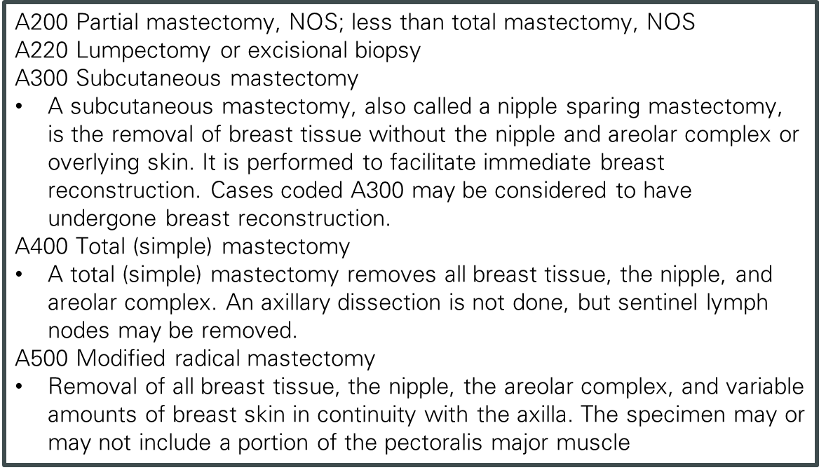

- Lumpectomy
  - A200
  - A220
  - A300
  - A400
  - A500
- Nipple Sparing Mastectomy
  - A200
  - A220
  - A300
  - A400
  - A500
- Skin Sparing Mastectomy
  - A200
  - A220
  - A300
  - A400
  - A500
- Simple Mastectomy with SLN Bx
  - A200
  - A220
  - A300
  - A400
  - A500
- Mastectomy with SLN Bx and Axillary Node Dissection
  - A200
  - A220
  - A300
  - A400
  - A500

- Poll#7 cT Category
Scenario | cT
A. PSA Elevated 7.5. No DRE available in the EMR, Prostate biopsy confirmed bilateral Adenocarcinoma Gleason 3+3 | Blank
B. PSA Elevated 7.5. No DRE available in the EMR, Prostate biopsy confirmed bilateral Adenocarcinoma Gleason 3+3, Radiation Oncologist stages as cT1c cN0 cM0 Stage 1 | Blank or cT1c
C. PSA Elevated 7.5, DRE: Prostate nodule present right lobe suspicious for malignancy. Prostate biopsy confirmed bilateral Adenocarcinoma Gleason 3+3 | cT2
D. PSA Elevated7.7.Per Urologist, DRE not done - telemedicine surgical consult only due to COVID.MRI 2.3cm suspicious area throughout majority of right gland & peripheral zone, extension into seminal vesicles, Pi-Rads 5,Biopsy: Gleason 7/4+3 in 12/12 cores both lobes of the prostate | Blank
E. Patient had TURP for chronic urinary retention and removal of bladder calculi. [No mention of DRE or PSA being performed in any documentation.] Path: Adenocarcinoma in less than 5% of tissue resected. | blank

- Poll#8 Difference Between M1a,M1b,M1c
Scenario:
Elevated PSA, DRE (-) Biopsy+ Adenocarcinoma Gleason 4+4, Scans show Bone Mets & Retroperitoneal Lymph Node Mets

Question:
How would you assign cM1?
- cM1Distant Mets
- cM1a Nonregional Lymph node(s)
- cM1b Bone(s)
- cM1c Other site(s) with or without bone disease

- Poll #9 Primary Site
Scenario:
Op report: TURB: 3cm tumor in the dome of the bladder & several smaller tumors covering the posterior and lateral walls sent for biopsy

Path Report: Bladder Tumor TURBT: Invasive high grade papillary urothelial carcinoma positive for lamina propria invasion muscularis propria present negative for invasion. Papillary urothelial carcinoma Right Lateral and Anterior Wall biopsy: Papillary urothelial ca, grade 1/3. No definitive evidence of invasion in subepithelial connective tissue. Muscularis propria is present, neg for ca.

Question:
What is the primary site?
- C671 Dome of the Bladder
- C678 Overlapping lesion of bladder
- C679 Bladder, NOS

- Poll #10 AJCC Pathological Stage
Scenario:
- Path: urinary bladder, transurethral resection:
- Histologic type: Urothelial carcinoma
- Variant histology: No
- Grade (WHO 2004) Low-Grade
- Tumor configuration: Papillary
- Microscopic extent of tumor: Noninvasive
- Muscularis propria Present: Yes

Question:
How would pathological stage be assigned?
- pTa cN0 cM0 Stage 0A
- pTa pNX cM0 Stage 99
- pT BLANK pN BLANK pM BLANK Stage 99

- Poll #11 T Suffix
Scenario:
TURB : 1 cm bladder tumor on left wall, 1cm bladder tumor on posterior wall which were both fulgurated, and 3 cm bladder tumor on the bladder dome which was resected and the base was fulgurated.
Pathology from TURB showed non-invasive urothelial cTa bladder cancers for all 3 tumors

Question:
How would the clinical T suffix be coded?
  - (m) multiple tumors
  - BLANK

- Poll#12 Cystoprostatectomy
Scenario:
Radical cystoprostatectomy with ileal conduit conversion and incidental appendectomy (appendix was not involved)

Question:
How would primary surgery be coded?
- A610 Radical cystectomy PLUS ileal conduit
- A710 Radical cystectomy including anterior exenteration

- Poll #13 Primary Site
Scenario:
  - CT Abdomen/Pelvis:13.1 cm right renal mass suspicious for renal cell carcinoma. Retroperitoneal lymphadenopathy. Soft tissue mass left adrenal gland concerning for mets.
  - Renal biopsy: transitional cell carcinoma

Question:
What is the primary site?
  - C649 Kidney
  - C659 Renal Pelvis

- Poll #14 Histology
Scenario:
Nephrectomy, Histology: Clear cell papillary renal cell carcinoma

Question: How would you code histology?
- 8310 Clear cell renal cell carcinoma
- 8260 Papillary renal cell carcinoma
- 8323 Clear cell papillary renal cell carcinoma
- 8050 Papillary carcinoma, NOS

- Poll#15 SSDI Invasion Beyond Capsule
Scenario
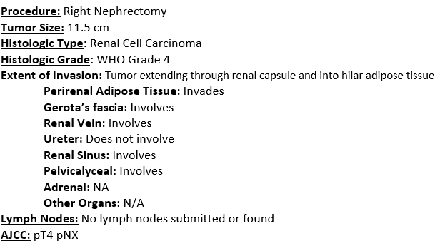

Question:
How would you assign SSDI Invasion Beyond Capsule?
- 1-Perinephric (beyond renal capsule) fat or tissue
- 2-Renal sinus
- 3-Gerota's fascia
- 4-Any combination of codes 1-3

- Poll#16 SSDI’s Confined Kidney-No Surgery
Scenario:
  - CT ab: 2.5cm mass right kidney consistent with renal cell carcinoma limited to the kidney, no evidence of lymphadenopathy or distant metastatic disease
  - Physician staged as cT1a cN0 cM0 Stage 1
  - Plan: Due to patient’s age and comorbid conditions no treatment active treatment recommended at this time will continue follow the patient with surveillance.
Question:
How would you assign SSDI Ipsilateral Adrenal Gland Involvement?
0 involvement not present/not identified
9 involvement not assessed or unknown if assessed

