Lung Cancer Case #1

History
71 yr-old male w/ h/o HTN, HLD, GERD, CAD, who presented w/ intermittent mild cough, nonproductive. Pt also reports some weight loss. Former heavy smoker. 25 PK-YR (Quit in 2018). -etoh. +FHX: Father diagnosed w/ lung cancer in his early 60s (also a heavy smoker).

Imaging Work-up:
11/2/22 @ ABC Hospital:
CT chest: Large 7.1 cm perihilar mass w/ associated abrupt cut-off of the LT mainstem bronchus. Prominent peribronchial thickening & consolidation of LLL. Evident mediastinal lymphadenopathy.
11/9/22 @ ABC Hospital:
PET/CT: Large FDG-avid centrally positioned LT lung & LT hilar mass consistent with neoplasm, likely bronchogenic carcinoma. FUV max 13. FDG-avid mediastinal lymphadenopathy consistent with metastatic disease, SUV max 11.
11/16/22 @ ABC Hospital:
MRI Brain: No evidence of metastatic disease.
Clinical Stage: IIIB: T4, N2, M0.

Pathology:
11/7/22 @ XXX Hospital: Endoscopic Bronchoscopy with Ultrasound
- Left mainstem bronchus biopsy= Squamous cell carcinoma, poorly differentiated with necrosis. Positive for p64. Negative for TTF-1.
- Station 7 LN, endoscopic US-guided FNA: squamous cell carcinoma, poorly differentiated,
- LT mainstem bronchus mass brushings: positive for malignant cells, squamous cell carcinoma, poorly differentiated,
- Bronchial washings: positive for malignant cells, squamous cell carcinoma, poorly differentiated,
- IHC for part B-C positive for p40, focally positive for Napsin A. Negative for TTF1, cytokeratin 7.

Treatment:
12/5/22 @ ABC Hospital: Carboplatin + paclitaxel X 13 cycles, concurrent with radiation therapy.
12/6/22-1/16/23 @ XXX Hospital: Left lung, 6X/IMRT, 2 Gy x 30 fx= 60 Gy.
3/13/22 @ ABC Hospital: Imfinzi (Durvalumab), Q14 days. Days 1-28, x 13 cycles.
SUMMARY OF RADIATION FIELDS
Course: C1 Lt Lung

Site | Ref. ID | Energy | Dose/Fx (cGy) | #Fx | Total Dose (cGy) | Start Date | End Date | Elapsed Days
Lt Lung | Lt Lung | 6X/IMRT | 200 | 30 / 30 | 6,000 | 12/6/2022 | 1/16/2023 | 41

Are lymph nodes within irradiated volume?
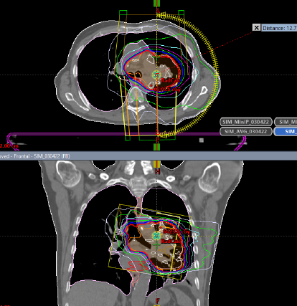
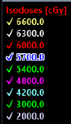
What are organs at risk (OARs) when the lung is irradiated?

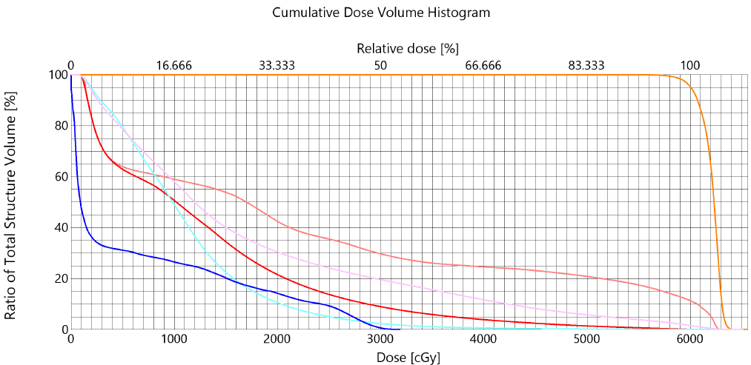
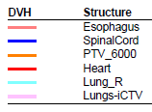

Lung Cancer Case #2

History:
69 yr-old female w/ h/o heavy smoking hx in the past (quit two yrs ago), who presented w/ screen-detected right lung cancer during low-dose screening chest CT. Patient is asymptomatic. -Etoh. +fhx: mother with lung cancer (smoker). Sister with endometrial cancer.

Imaging Work-up:
12/8/22 @ AAA Hospital:
CT chest: 4.4 cm mass-like opacity in right upper lobe, concerning for neoplastic process. Indeterminate right hilar lymphadenopathy.
12/16/22 @ AAA Hospital:
PET/CT: FDG-avid 4.9 cm mass in RUL consistent with bronchogenic carcinoma. No other FDG-avid activity seen.
Clinical Stage IIA: cT2b, N0, M0

Pathology:
1/3/23 @ AAA Hospital:
- RUL navigational bronchoscopy= positive for malignancy, squamous cell carcinoma.
- Bronchial wash= positive for malignancy, squamous cell carcinoma

Treatment:
Surgery- 1/9/23 @ AAA Hospital:
Robotic-assisted RUL lobectomy with mediastinal lymph node dissection: 6.1 cm invasive squamous cell carcinoma, keratenizing @ RUL. Grade 2. Visceral pleural invasion present. Involves parietal pleura. No Lymphovascular invasion. All resection margins are negative, closest at parenchyma, 1.1 cm.
Number of LNs examined= 21
Number of LNs involved= 0.
Lymph nodes examined: 4R, 8R, 10R, 11R, 12R, 13R, subcarinal.
Pathologic stage: pT3, pN0.

Chemotherapy on 2/20/23 @ AAA Hospital: Carboplatin + paclitaxel concurrent with EBRT.
Radiation Therapy- 2/20/23-4/3/23 @ ZZZ Hospital:

SUMMARY OF RADIATION FIELDS

Site | Energy | Dose/Fx (cGy) | #Fx | Total Dose (cGy) | Start Date | End Date
RT Lung | 6X/VMAT | 200 | 30 / 30 | 6,000 | 2/20/23 | 4/3/23

Are lymph nodes within irradiated volume?

Lung Cancer Case #3

History:
60 yr-old male w/ h/o GERD, HTN, HLD, who presented w/ interval change in size of known right upper lobe lung nodule. Former heavy smoker. Social etoh. -FHX.

Imaging Work-up:
10/11/22 @ ABC Hospital:
CT chest: Increase in previous RUL lung lesion, now measuring 0.9 cm (previously measured 0.4 cm), concerning for primary pulmonary neoplasm. No mediastinal/thoracic lymphadenopathy.
10/25/22 @ ABC Hospital:
PET/CT: RUL hypermetabolic uptake in 2.0 cm mass, consistent with index tumor activity. No other FDG-avid activity seen.
11/2/22
- RUL navigational bronchoscopy= positive for malignancy, squamous cell carcinoma

OnkoSight Advanced Lung Cancer NGS Report:
11/2/22
Detected Genomic Alterations:
Tier II: Variants of Potential Clinical Significance:
- KRAS
- POLD1 p
- TP53p
Tier III: Variants of Unknown Clinical Significance (VUS):
- ATR p
Immunotherapy Biomarkers:
Tumor Mutation Burden: Low (3.5 Mutations/MB)
Microsatellite Instability: MSI Negative (0%)
Pertinent Negative Results:
AKT1, ALK, BRAF, CHEK1, DDR2, EGFR, ERBB2, FGFR1, MAP2K1M, MET, NRAS, NTRK1, PIK3CA, POLE, ROS1, STK11, TERT.
KEYTRUDA PD-L1 Immnuhistochemical Analysis (NSCLC):
Tumor Proportion Score <1%/Negative.
Clinical Stage:

Surgery Pathology:
11/14/22 @ ABC Hospital:
- Robotic-assisted RUL wedge resection & lobectomy= 2.1 cm invasive squamous cell carcinoma, basaloid, G1. Positive for visceral pleural invasion. No LVI. Margins negative. Regional lymph nodes= 0/12 negative. (LNs stations examined: 4R, 8R, 9R, 10R, 11R, 7L). Pathologic stage 1A2: pT1b, pN0.

Treatment:
Surgery- 11/14/22 @ AAA Hospital: Robotic-assisted RUL wedge resection & lobectomy with regional mediastinal lymph node dissection.

Radiation Therapy- 11/28/22-1/9/23 @ ZZZ Hospital:

SUMMARY OF RADIATION FIELDS

Site | Energy | Dose/Fx (cGy) | #Fx | Total Dose (cGy) | Start Date | End Date
RT Lung | 6X/SBRT | 800 | 5/5 | 4,000 | 11/28/22 | 12/2/23

