Quiz 1-Class of Case

- A patient was diagnosed with breast cancer at another facility. She then came to your facility for an FNA of an enlarged lymph node. The FNA was positive for metastatic breast cancer. The patient went elsewhere for surgery and adjuvant treatment.
  - 00 Initial diagnosis at the reporting facility AND all treatment or a decision not to treat was done elsewhere
  - 14 Initial diagnosis at reporting facility AND all first course treatment or a decision not to treat was done at the reporting facility
  - 21 Initial diagnoses elsewhere AND part of first course treatment or a decision not to treat was done at the reporting facility
  - 30 Initial diagnosis and all first course treatment elsewhere AND reporting facility participated in diagnostic workup (for example, consult only, treatment plan only, staging workup after initial diagnosis elsewhere)
- A patient is diagnosed with lung cancer at your facility. The patient does not return for staging work-up or treatment consultation. You do not know if the patient went elsewhere for additional work-up or treatment. The class of case would be...
  - 00 Initial diagnosis at the reporting facility AND all treatment or a decision not to treat was done elsewhere
  - 10 Initial diagnosis at the reporting facility or in a staff physician’s office AND part or all of first course treatment or a decision not to treat was at the reporting facility, NOS
  - 12 Initial diagnosis in staff physician’s office AND all first course treatment or a decision not to treat was done at the reporting facility
  - 30 Initial diagnosis and all first course treatment elsewhere AND reporting facility participated in diagnostic workup (for example, consult only, treatment plan only, staging workup after initial diagnosis elsewhere)
- A patient was diagnosed at your facility and then referred to a non-staff medical oncologist. The Medical Oncologist did not recommend treatment due to co-morbid disease. The patient did not seek any additional consultations and did not get any treatment. The patient was eventually admitted to a hospice facility. What is the Class of Case for this patient?
  - 00 Initial diagnosis at the reporting facility AND all treatment or a decision not to treat was done elsewhere
  - 11 Initial in a staff physician’s office AND part of first course treatment or a decision not to treat was at the reporting facility, NOS
  - 14 Initial diagnosis at reporting facility AND all first course treatment or a decision not to treat was done at the reporting facility
  - 30 Initial diagnosis and all first course treatment elsewhere AND reporting facility participated in diagnostic workup (for example, consult only, treatment plan only, staging workup after initial diagnosis elsewhere)

- A patient was diagnosed with cancer in a physician’s office by a physician with staff privileges at Hospital A and Hospital B. The patient underwent surgical resection at Hospital A and chemotherapy at Hospital B. Class of case for Hospital B is …
  - 00 Initial diagnosis at the reporting facility AND all treatment or a decision not to treat was done elsewhere
  - 11- Initial diagnosis in staff physician’s office AND part of first course treatment was done at the reporting facility
  - 12- Initial diagnosis in staff physician’s office AND all of first course treatment was done at the reporting facility
  - 21- Initial diagnosis elsewhere AND all first course treatment or a decision not to treat was done at the reporting facility

- Class of case 00 includes which of the following scenarios?
  - Diagnosed at the reporting facility and treatment given in the staff physician's office
  - Diagnosed in a staff physician’s office and treated in the same staff physician's office
  - Diagnosed at the reporting facility and treated in a non-staff physician’s office
  - Diagnosed at the reporting facility. Patient never returned. It is unknown if the patient received treatment
  - All of the above
  - A and C only
  - A, B and C only

Match the situation to the correct Class of Case from the choices below (Use each value once):

a) Patient diagnosed with breast cancer at local clinic and travels to reporting facility for surgery.

b) Patient dies in ED at reporting facility. Subsequent autopsy reveals previously undiagnosed pancreatic cancer.

c) Diagnostic radiology at reporting facility identifies tumor in posterior fossa. Patient undergoes craniotomy at another facility for removal of hemangioblastoma.

d) Diagnosed with cancer via a biopsy at the reporting facility, the patient does not return for further workup and/or treatment. No other information available.

e) Person in town on business is admitted for an unrelated issue and receives one of their chemotherapy treatments while an inpatient.

f) Patient has suspicious polyp removed during colonoscopy which is positive for in situ adenocarcinoma.

g) Following a diagnosis of pancreatic cancer at their local hospital, the patient has a Whipple procedure at your facility. Returns home for adjuvant chemotherapy.

h) Patient with history of LUL lobectomy presents two years later with recurrent large cell neuroendocrine carcinoma.

00 __ 10 __ 14 __ 20 __

21 __ 31 __ 32 __ 38 __

Quiz 2-Terminology

- Write the standard abbreviation or symbol as documented in NAACCR Recommended Abbreviations for Abstractors
  - Alcohol
  - Well Differentiated
  - Hispanic Female
  - Consistent With
  - Date of Birth
  - Right Upper Outer Quadrant
  - No Evidence of Disease
  - Positive
- Match the prefix/suffix with the best definition.
Peri |  | A: excessive, above normal
Para |  | B: pain
Oma |  | C: tumor
Sub |  | D: around or about
Hyper |  | E: alongside of, near
Dys |  | F: of or pertaining to the wrist
Dynia |  | G: abnormal
Carp(o) |  | H: under, below

- Match the standard abbreviation with the definition
@ |  | A: Squamous Cell Carcinoma
SLNBX |  | B: Differentiated/differential
SQCC |  | C: Hormone Replacement Therapy
DCIS |  | D: Sentinel Lymph Node Biopsy
DIFF |  | E: Postoperative(-ly)
HRT |  | F: At
POST |  | G: Posterior
POST OP |  | H: Ductal Carcinoma IN Situ

- Match the organ with the regional lymph nodes.
Lung |  | A: Hepatic
Breast |  | B: Retroperitoneal
Larynx |  | C: Intramammary
Ovary |  | D: Cervical
Stomach |  | E: Hilar
Liver |  | F: Pelvic
Kidney |  | G: Pyloric

- Match the organ with the surgical procedure
Tongue |  | A: Anterior temporal lobectomy
Breast |  | B: Gastrectomy
Lung |  | C: Glossectomy
Stomach |  | D: Cystectomy
Uterus |  | E: Lumpectomy
Bladder |  | F: Pneumonectomy
Brain |  | G: Hysterectomy

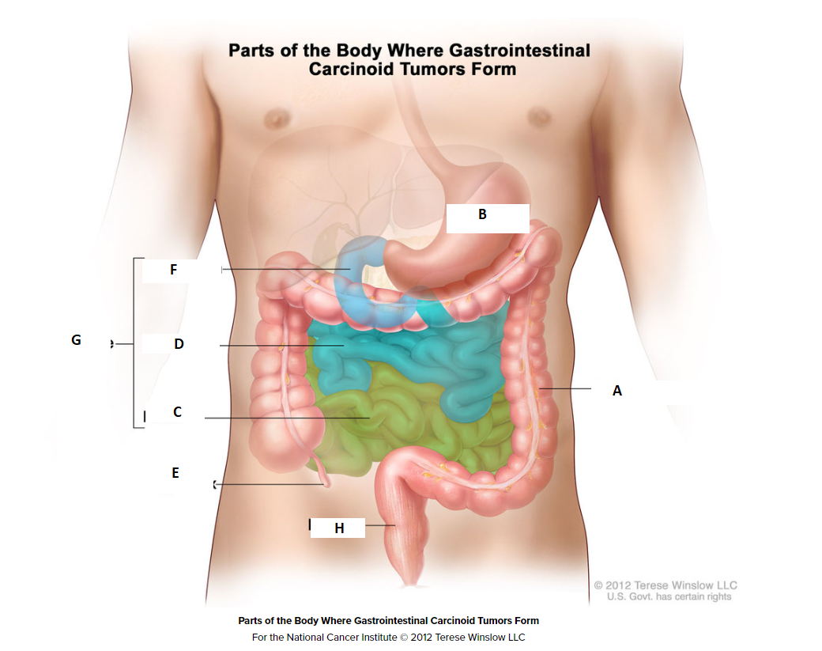
Write the letter of the corresponding parts of next to the description
Ileum
Duodenum
Appendix
Small intestine
Rectum
Colon
Jejunum
Stomach

- A paracentesis is done to…
  - Remove fluid from the abdomen
  - Evaluate lymph nodes for malignancy
  - To help control the side effects of chemotherapy
  - To amplify the effectiveness of radiation

- A malignant pleural effusion is most likely related to
  - A CNS primary
  - A prostate primary
  - A breast primary
  - A lung primary
- Which of the following correctly describes the layers of the stomach wall?

  - Mucosa, Submucosa, Muscle Layer, Subserosa, Serosa
  - Visceral peritoneum, blood vessel, serosa, Muscle layer, Submucosa
  - Epidermis, Dermis, Subcutaneous Tissue
  - None of the above

- Which of the following is the point at which the trachea divides into the right and left mainstem bronchus?
- Lingula
- Hilum
- Carina
- Mediastinum

- The supraglottis is within the:
- Esophagus
- Larynx
- Pharynx
- Stomach

- What carries oxygenated blood from the lungs to the heart?
- Capillaries
- Lymphatic vessels
- Pulmonary arteries
- Pulmonary veins

- The parietal peritoneum:
- Covers portions of the lung
- Lines the abdominal and pelvic walls
- Covers all of the abdominal organs
- Connects the colon to the abdominal wall

- The site of origin of a leiomyosarcoma is most likely the:
- Cervix
- Endometrium
- Myometrium
- Ovary

- Subcarinal lymph nodes are regional nodes for:
- Lung
- Pancreas
- Rectum
- Stomach

Quiz 3-Casefinding

Circle Yes if the situation is reportable and No if the situation is not reportable according to STORE. Assume all cases diagnosed in 2018 or later.
  - Yes No Serous Cystadenoma with borderline malignancy of the ovary
  - Yes No Polycythemia, NOS
  - Yes No Carcinoma in situ of the cervix with micro invasion
  - Yes No MRI of the brain: Lesion in the occipital lobe of the brain.
  - Yes No MRI of the brain: A small pituitary tumor
  - Yes No Cytology from a paracentesis: probable malignant ascites.
  - Yes No Suspicious breast mass, suspicious for malignancy
  - Yes No Potentially malignant lung mass
Indicate whether the following diagnoses would be reportable, based on the terms provided:
Yes No
a) Tumor in RUL, very likely malignant ___ ___

b) Nodule in L lobe of prostate suspicious for malignancy ___ ___

c) IVP reveals potentially malignant nodule on R kidney ___ ___

d) Urine cytology consistent with urothelial cell carcinoma ___ ___

e) Suspicious neoplasm in R occipital lobe ___ ___

f) 2cm Hypoechoic irreg. mass L breast @ 10:00 worrisome for ca. ___ ___

g) Peripheral blood: findings are consistent with B Lymphoblastic lymphoma ___ ___

h) Multiple Lesions across back, chest, arms, face, and legs most likely Kaposi sarcoma ___ ___
1. Which one of the following best describes the sequence number?
- The order in which a primary tumor was accessioned into the facility’s database
- The order in which a primary tumor is discovered in relation to the total number of reportable tumors the patient has been diagnosed with
- The number of malignant tumors over the lifetime of the patient
- The total number of tumors reportable to the CoC

- A patient was diagnosed and treated at your facility three years ago with a carcinoma in situ of the cervix. Your facility collects carcinoma in situ of the cervix as a reportable by agreement case. The patient now presents with a new diagnosis of lung cancer and a benign brain tumor. Assuming the patient has no additional reportable malignancies assign a sequence to each primary.
  - Carcinoma in situ of the cervix __ __
  - Lung __ __
  - Benign brain tumor __ __

- A patient was diagnosed and treated at your facility three years ago with a meningioma (9530/0) over the left temporal lobe. The patient now presents with a new diagnosis of adenocarcinoma of the lung (8140/3) and a neurofibroma (9540/0) in the central nervous system. Assuming the patient has no additional reportable malignancies assign a sequence (sequence hospital) to each primary as it would look today.
  - Meningioma __ __
  - Lung __ __
  - Neurofibroma __ __

- The resource that defines all diagnoses and types of cases that should be included and excluded from the registry database is called the:
  - Suspense system
  - Reportable list
  - Class of case
  - Abstract

- Casefinding is the systematic method of identifying what?
  - The number of cases seen by the hospital each year
  - All eligible cases that are to be included in the cancer registry database
  - All cases that were diagnosed in the pathology department
  - The number of patients that are treated in the hospital
  - The number of admissions as identified on the HIM disease indices

- Which of the following statements INCORRECTLY describes a case eligibility rule?
  - Juvenile astrocytoma diagnosed in 2023 should be recorded in the registry database with a behavior code of /3
  - Malignant primary skin cancers (primary site code of C44.) with a histology code in the range of 8000-8110 are not required to be reported by the CoC as of 1/1/2003
  - Carcinoma in situ of the cervix (CIS) is not required by the CoC
  - Basal Cell carcinoma of the skin is not required by the CoC.

- Which of the following cases are reportable to the CoC?
  - Melanoma (8720/3) of the skin of the arm (C44.6)
  - Squamous cell carcinoma (8070/3) of the anus (C21.0)
  - Subependyoma (9383/1) of the frontal lobe (C71.1)
  - Carcinoid (8420/3) of the appendix (C18.1)
  - All of the above

- Which of the following is an analytic case?
  - The patient is diagnosed at your facility and sent elsewhere for treatment
  - The patient receives treatment at your facility for a recurrence. There is no information on first course of treatment available.
  - The diagnosis is established by death certificate only
  - Your facility manages or treats a recurrence or progression of disease after the reference date
  - Cancer is diagnosed at autopsy. Prior to autopsy there was no suspicion or diagnosis of cancer.

- Which of the following is a non-analytic case?
  - The patient is diagnosed at your facility and it is unknown whether or not treatment was recommended or administered.
  - The patient is diagnosed at the facility and is referred elsewhere for treatment.
  - The patient was diagnosed and treated for a malignancy elsewhere, and presents to your facility for treatment for recurrence or progression of disease.
  - The patient is diagnosed elsewhere, and all or part of the first course of treatment is performed at the facility.

Quiz 4-Manuals

A patient was diagnosed with pancreatic cancer on 7/13/2020. You are abstracting the case today (3/2/2023). Which version of the following manuals would you use?
- STORE Manual
  - STORE 2018
  - STORE 2021
  - STORE 2022
  - STORE 2023

- Solid Tumor Manual
  - 2007 Multiple Primary and Histology Manual
  - Solid Tumor Manual (July 2019 Update)
  - Solid Tumor Manual (September 2021 Update)
  - Solid Tumor Manual (2023 Update (most current version))

- Your State, regional, provincial, or territorial manual
  - 2018 version
  - 2020 version
  - 2021 version
  - 2023 version
  - Other

A patient was diagnosed with medulloblastoma on 1/15/23. You are abstracting the case today (3/2/2023). Which version of the following manuals would you use?
- Summary Stage 2018
  - Version 2.0 (released January 2021)
  - Version 2.1 (released January 2022)
  - Version 3.0 (release January 2023)
- SSDI Manual
  - Version 2.0 (released January 2021)
  - Version 2.1 (released January 2022)
  - Version 3.0 (release January 2023)

Quiz 5-Colorectal

- Site-specific Data Items replaced:
- AJCC Staging
- Tumor Markers
- Collaborative Stage v2
- NCDB

- Increased CEA values may indicate:
  - Biliary obstruction
  - Colorectal cancer
  - Alcoholic Hepatitis
  - Heavy Smoking
  - All of the above

- When coding multiple pretreatment CEA lab values:
  - Record first test value prior to treatment
  - Record the highest value prior to treatment
  - Record normal value prior to treatment
  - Record lower value prior to treatment

- CEA is a protein molecule produced in many different cells of the body but associated with gastrointestinal cancers.
  - True
  - False

- Circumferential Resection Margin is also known as:
  - Ileostomy margin
  - Mesenteric resection margin
  - Lymph node dissection
  - Colonoscopy

- When colon is completely encased by the peritoneum, the only relevant margin is:
  - Mesenteric margin
  - Appendiceal margin
  - Peritoneal margin
  - Abdominal soft tissue

- When margins are positive code:
  - XX.9
  - XX.2
  - 0.0
  - XX.0

- When the margin is described as less than 0.1 mm with no more specific measurement code:
  - 0.1
  - 0.0
  - XX.0
  - XX.2

- For colon biopsy, code Circumferential Resection Margin:
  - XX.9
  - 0.0
  - 0.88
  - XX.7

- Production of KRAS indicates:
  - Adverse prognostic factors
  - Tumor remission
  - Poor response to anti-EFGR antibody therapy
  - A & C
  - All of the above

- Mutated KRAS codons are rarely mutated in colorectal cancers.
  - True
  - False

- High MSI may indicate:
  - 5FU chemotherapy is effective treatment
  - Lynch Syndrome
  - Unaffected DNA
  - Tumor tissue with certain non-functioning sections of DNA
  - All of the above
  - B & D

- Perineural Invasion is:
  - Infiltration of regional lymph nodes
  - Infiltration of nerves in area of lesion
  - Distant Metastasis
  - Margin status

- If surgical resection is performed and no mention of the perineural invasion code:
  - 8
  - 0
  - 1
  - 9

- Tumor Deposits are defined as:
  - Lymph node metastasis
  - A discrete nodule within the liver
  - A discrete nodule in pericolic/perirectal fat
  - Distant metastasis

- Code X9 in SSDI tumor deposit field when:
- Tumor deposit is not documented in medical record
- No surgical resection is done
- Pathology report is not available
- Tumor deposits are not evaluated
- All of the above

- Clinical guidelines recommend BRAF mutational analysis for patients with:
  - In Situ Disease
  - Local Disease
  - Regional Disease
  - Metastatic Disease

- BRAF oncoprotein is involved in transmitting cell growth and proliferation signals from CEA.
  - True
  - False

- NRAS is a new data item for cases diagnosed:
  - 1/1/2018 and forward
  - 1/1/2020 and forward
  - 1/1/2021 and forward
  - 1/1/2022 and forward

- NRAS is recorded for:
  - All stages
  - Metastatic disease only
  - Assessment of perineural involvement
  - Local disease only

Quiz 6- Corpus Uteri

- If FIGO Stage is provided from clinical & pathological work up:
- Code the pathologic stage
- Code the clinical stage
- Code most extensive FIGO stage
- Code the sage as 99

- Para-aortic nodes include:
  - Aortic
  - Lateral Aortic
  - Lumbar Aortic
  - Periaortic
  - All of the above

- Pelvic Nodes include:
  - Axillary and mammary
  - Iliac and parametrial
  - Hilar and Mediastinal
  - Infraclavicular and Pre-Auricular

- You can attempt to code FIGO stage based only on T, N, and M
  - True
  - False

- For Endometrial Intraepithelial Neoplasia (EIN), the FIGO stage is:
  - 0
  - TIS
  - 97
  - 1

- When no para-aortic lymph nodes are removed, but an aspiration or core biopsy of para-aortic nodes was performed code:
  - 00
  - X6
  - X1
  - X9

- Where would you find peritoneal cytology reports:
  - Pathology Reports
  - Op Notes
  - Radiology Reports
  - Lab reports

- Ascites is:
  - A procedure to remove
  - A group of lymph nodes
  - A neoplasm in the stomach
  - Excess natural fluid accumulation in the abdominal cavity

- If no para-aortic lymph nodes are examined code:
  - X6
  - Leave it blank
  - 00
  - X9
  - X2

- FIGO provides which of the following for gynecologic malignancies?
  - Stage criteria for primaries of the cervix
  - Stage criteria for primaries of the endometrial
  - Grade criteria for endometrial
  - All of the above

- The number of positive lymph nodes must ALWAYS be less than or equal to number of nodes examined
  - True
  - False

- Involvement of regional and distant lymph nodes is an important prognostic factor:
  - True
  - False

Case Scenario:
70F with Bx-proven FIGO Grade 2 adenoca of the uterus. Pt reported several month hx of vaginal bleeding. A CT scan showed a thickened endometrium that was not present on prior imaging, but no evidence of mets disease. Plan: TAH-BSO.

Path Report #1
FINAL DIAGNOSIS
A) Uterine contents, dilation, and curettage: Endometrioid adenocarcinoma (FIGO grade II).

Path Report #2
FINAL DIAGNOSIS
A) Uterus, cervix, bilateral tubes and ovaries, hysterectomy and bilateral salphingo-oopherectomy:
- Endometrial adenocarcinoma, FIGO grade 2, endometrioid with focal mucinous features, superficial myometrial invasion and areas suspicious for angiolymphatic invasion (extensive knife carryover hinders evaluation)
- Bilateral fallopian tubes and ovaries negative for neoplasm
- Myometrium with intramural leiomyoma nodules.
- See Cancer Summary Data.
B - E) Lymph nodes, as designated, excisions: Multiple lymph nodes negative for neoplasm including 4 left pelvic, 7 right pelvic, 1 right obturator and 6 left obturator.
SUMMARY CANCER DATA
Specimen type: Hysterectomy.
Other organs present: Right ovary, left ovary, right fallopian tube, Left fallopian tube.
Specimen integrity: Intact hysterectomy specimen.
Chemotherapy and/or radiation therapy prior to surgery: Unknown/History not provided.
Characteristics and Extent of Neoplasm:
Histologic type: Endometrioid carcinoma, NOS (83803).
Histologic grade: FIGO G2: 6% to 50% non-squamous solid growth OR <6% solid with high nuclear grade.
Tumor size: Greatest diameter: 3 cm.
Tumor site (epicenter): Endometrium of fundus (C54.1).
Myometrial invasion: Depth of invasion: 0.7cm / Myometrial thickness: 2cm.
Lower uterine segment: Carcinoma invades LUS stroma.
Cervix and endocervix: Negative for carcinoma.
Extra-uterine involvement: No extra-uterine involvement.
Venous/lymphatic (large/small vessel) invasion: Indeterminate.
Margin Status: All margins are widely free of carcinoma.
Lymph Node Status:
- Pelvic node summary: Nodes with carcinoma: 0 / Total nodes examined: 18.
- Para-aortic node summary: Nodes with carcinoma: 0 / Total nodes examined: 0.
Minimum Pathologic Stage (AJCC, 8th ed.):
- Primary tumor (pT): pT1a: Tumor limited to endometrium or invades less than one-half of myometrium.
- Regional lymph nodes (pN): pN0: No regional lymph node metastasis.
Minimum FIGO Stage: FIGO Stage: IA: Tumor limited to endometrium or invades less than half of myometrium.

Path Report #3
SPECIMEN SOURCE
A) Pelvic wash
SPECIMEN DESCRIPTION
30 ML CLOUDY FLUID IN SPECIMEN CUP WITH "PELVIC WASH" WRITTEN ON LABEL
CYTOLOGIC IMPRESSION
Pelvic washing: Negative for malignancy. See comment.
Number of Positive Para-aortic Nodes: ___
Number of Examined Para-aortic Nodes: ___
Number of Positive Pelvic Nodes: ___
Number of Examined Pelvic Nodes: ___
Peritoneal Cytology: _
FIGO Stage: ____

